
ATAR Biology

Unit 1: Topic 2
Week 6 – Biogeochemical Cycling

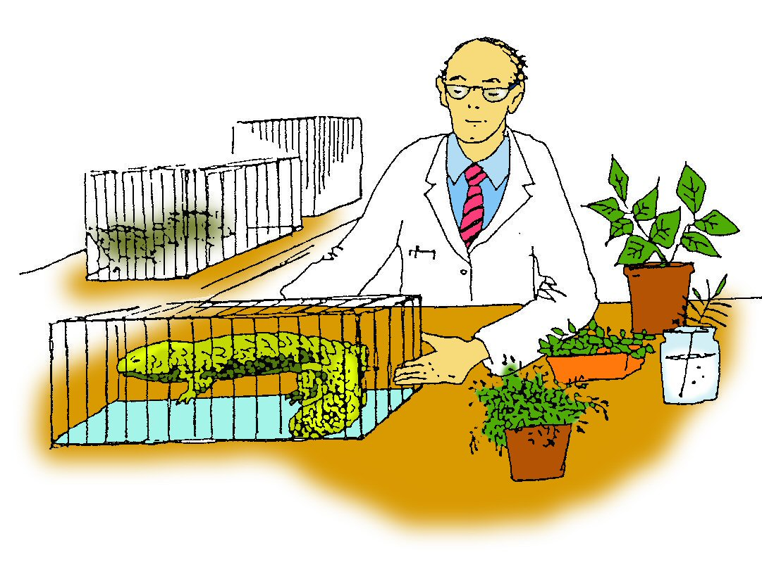

Student Study Notes

Unit Content
- The biotic components of an ecosystem transfer and transform energy and interact with abiotic components to facilitate biogeochemical cycling, including carbon and nitrogen cycling.

Cycling of matter
Energy flows through an ecosystem, but matter does not usually leave an ecosystem. Matter, such as carbon and nitrogen, cycles between the biotic and abiotic environment. Carbon and nitrogen are essential abiotic components of the community.

The Carbon Cycle
The element carbon is central to all life forms. Carbon is taken in from the environment, used by living organisms, and then returned to the environment in a continuous cycle.

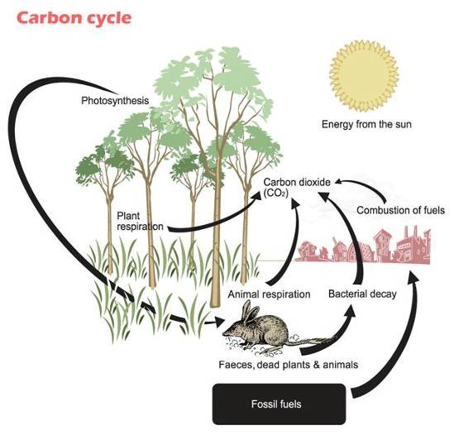

- Carbon enters the living system as carbon dioxide during photosynthesis.
- The carbon is transferred from plants to animals along food chains and returns to the air as carbon dioxide during cellular respiration.
- Bacteria acting on faeces, dead plants and animals also release carbon dioxide to the air.
- Additional carbon, trapped in fossil fuels, is released into the air during their combustion.

The Nitrogen Cycle
The element nitrogen is a vital component of all proteins. Nitrogen is taken in from the environment, used by living organisms, and then returned to the environment in a continuous cycle.

The nitrogen cycle is quite complicated and involves plants, bacteria and a few chemical changes. Nitrogen is needed by plants to make proteins. There is plenty of nitrogen gas in the air, but plants cannot use it in this form. Why?

Plants cannot break the strong bonds holding two nitrogen atoms (N2) together. Atmospheric nitrogen (N₂) is unavailable for use by most organisms because there is a triple bond between the two nitrogen atoms, making the molecule almost inert. For nitrogen to be used it must be 'fixed' (combined) with hydrogen to form ammonium (NH₄⁺) or with oxygen to form nitrate (NO₃⁻) ions.

Nitrogen needs to be converted or 'fixed' (combined) into a soluble form called nitrate before it can be absorbed through the roots of plants to make protein.

Nitrogen fixation is a process which converts nitrogen gas into soluble nitrates. Nitrogen fixation can occur through:
- nitrogen-fixing bacteria which live in swollen nodules on the roots of plants called legumes (Rhizobium)
- lightning strikes
- nitrogen-fixing bacteria which live in the soil (Azotobacter).

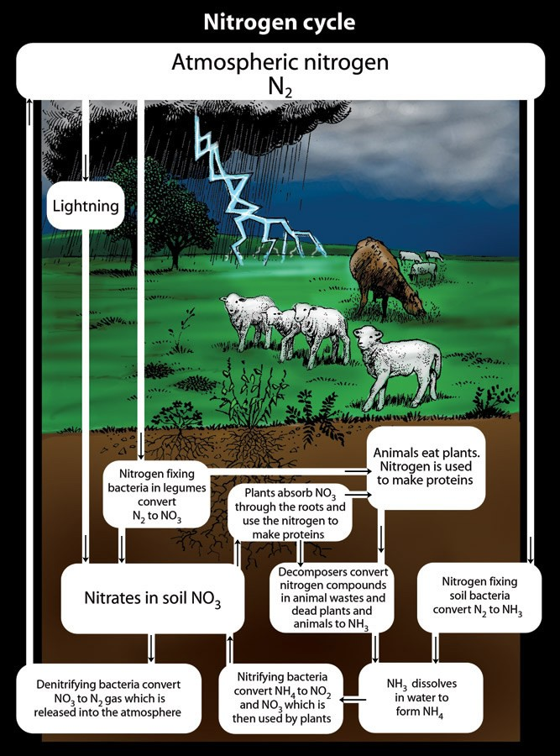
Nitrifiers or nitrogen fixing bacteria also play a role in the nitrogen cycle. These bacteria convert ammonia that is produced by decomposers or from the urine and faeces of animals, into nitrites (Nitrosomonas) and then nitrates (Nitrobacter).
PRACTICE QUESTIONS:

1. Use the flow diagram shown below to answer the following questions.

Task 5: Extended response – Energy transfer in ecosystems

Click here to access Task 5: Extended response – Energy transfer in ecosystems. Click here to access the student rubric.
Double click here to show answers.
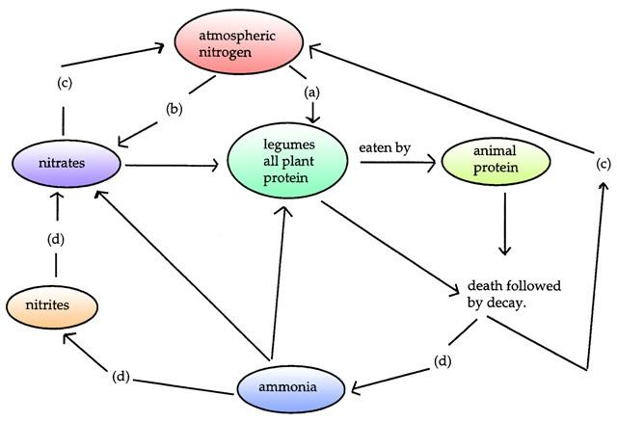

- Give names to the processes a, b, c, d.

- Explain how process (a) works and name an organism responsible.

- Explain the importance of process (d) and name an organism responsible.

- Nitrogen is an important part of which organic compounds found in organisms?

- Briefly explain how animals obtain nitrogen.

2. Refer to the graph provided to answer the questions below.

Carbon dioxide concentration in the air/24 hours
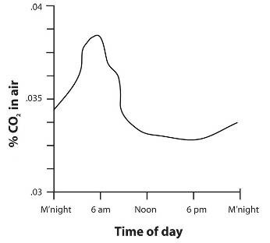

- When is the carbon dioxide concentration highest?

- When is the carbon dioxide concentration lowest?

- Suggest a likely explanation for the daily changes in carbon dioxide concentration.

Use the diagram below to answer questions 3 & 4.

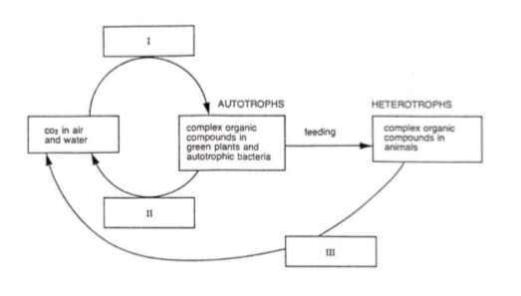

3. Process I would best be called:
- Chemosynthesis
- Respiration
- Photosynthesis
- Diffusion

4. Processes II and III would best be called:
- Chemosynthesis
- Respiration
- Photosynthesis
- Diffusion

Questions 5 – 8 relate to the following diagram.
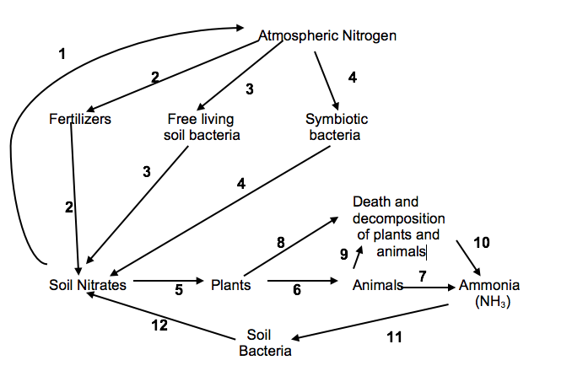
- Which label/s refer to nitrogen fixation?
- 1
- 1, 3
- 3, 4
- 2, 3, 4

- Which label/s refer to denitrifying bacteria?
- 1
- 3
- 4
- 12

- Which label/s represent nitrifying bacteria?
- 3
- 4
- 5
- 12

- Which label represents the uptake of inorganic nitrogen and the conversion of the nitrogen into amino acids?
- 5
- 6
- 7
- 10

9. Explain, with the aid of a large and clearly labelled diagram, how carbon dioxide from the air enters the living component of an ecosystem. You will need to refer to your text and other resources to gain more information.

Make sure:

- your diagram shows how carbon dioxide is used by both plants and animals

- your diagram shows ways in which carbon dioxide returns to the non-living environment.

